

Gerês

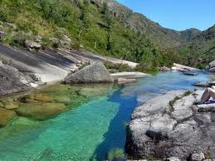

http://www.google.pt/images

Slogan

If you want to visit Portugal, go to Gerês. In this place you can take a breath and, who knows, you can also live!

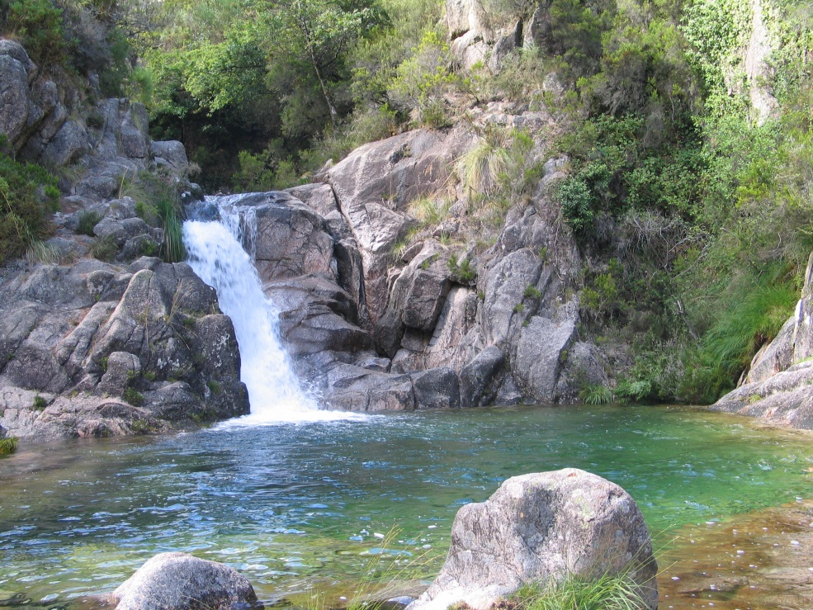

www.sunofportugal.com

If you want to visit Portugal, go to Gerês. In this place you can take a breath and who knows, you can also live!

In this place you can find a little of nature, peace, beautiful landscapes, fresh air, and go for a long walk.
To the photography fans, it is a good place to take amazing pictures.
It is also a nice place to those who want to take family holidays .
It has delicious food too.

Efa/S13
Sandra Santos
Formador: Pedro Antunes

